**Ingredients:**  
*(Serves 2-3)*  
  
  
  
3-4 medium red potatoes, cut into small wedges  
3 TBS olive oil  
1/3 C parmesan cheese *(fresh is great, but expensive, so I use “shaker parm”)*  
1 1/2 tsp garlic salt  
1 tsp paprika  
sea salt to taste

Preheat the oven to 425 F. Wash and dry the potatoes then cut each potato in half length wise, then cut each half into 4 or 5 wedges, then cut those wedges in half. Sort of like this:  
  
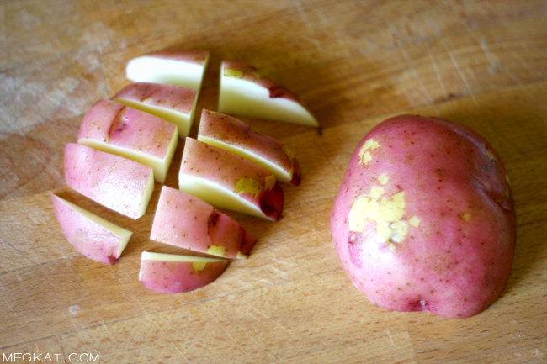  
  
In a small bowl, combine the parmesan, garlic salt, and paprika and set aside. Next, toss the potatoes and oil together in a mixing bowl then add the bowl of cheese and seasonings and stir to coat. Dump onto a cookie sheet and arrange in a single layer.

In a small bowl, combine the parmesan, garlic salt, and paprika and set aside. Next, toss the potatoes and oil together in a mixing bowl then add the bowl of cheese and seasonings and stir to coat. Dump onto a cookie sheet and arrange in a single layer.

Bake for about 25 minutes then remove from oven and turn over all the potatoes. It takes a few minutes but it is SO worth the time.  
  
In the picture below I’ve already flipped over the potatoes on the left. See how lovely, crispy, and brown thy get? Yum!

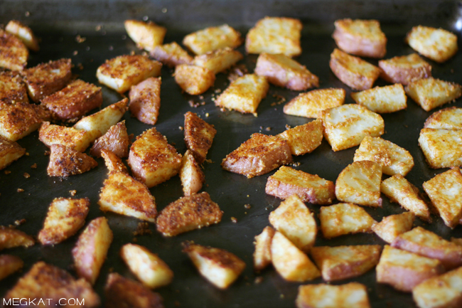

Put them back in the oven for another 10 or 15 minutes until they’re sufficiently crispy and divine.  
  
Now pile them on a plate, season with a little sea salt if needed, and try not to burn your tongue :)  
  
  
  
Bake for about 25 minutes then remove from oven and turn over all the potatoes. It takes a few minutes but it is SO worth the time.  
  
In the picture below I’ve already flipped over the potatoes on the left. See how lovely, crispy, and brown thy get? Yum!

Put them back in the oven for another 10 or 15 minutes until they’re sufficiently crispy and divine.  
  
Now pile them on a plate, season with a little sea salt if needed, and try not to burn your tongue :)

<http://megkat.com/2010/05/parmesan-roasted-potatoes.html>